

**Orange Coding Academy**

**Master Project Report**

ShareBook

**Prepared by:**

Farah Ali Al-Habrnih

**ShareBook Website**

**Project Brief:**

The idea of my project will be for selling used books. So, this web application is considered important to the people who suffer from high book prices in the market, so the website will offer him used books of suitable quality at competitive prices and at hand.

The user can browse the site and the books offered, and then add the book to his cart, fill in his personal information, and then purchase the book.

Each user can modify his personal information on the site.

Any guest can access this application and then add books to the cart without checkout and place order.

**Problem & Solution:**

The site addresses a problem that exists in the market, which is that the prices of the books offered are high, so the site offers used books of suitable quality at competitive prices and at hand.

**Programming Languages:**

Front-End: HTML, CSS, JS, Bootstrap

Back-End: PHP, Laravel, MySQL

**Project Features:**

1) The website implements SEO.

2)The website considers UX/UI design principles of all ages mentalities.

3) The website is fully responsive.

4) The website considers security by hashing strong passwords and activating the authorization demanding the user's role.

**Project Functionality:**

1) The user can create an account and register his personal information.

2) Users can explore all the books on the website and other sections without logging in.

3) Users can filter the books based on categories.

4) The user can preview the book's single page and other information about the book.

5) The user can add the book to the cart.

5) The user can checkout and place an order.

**Use Case Diagram:**

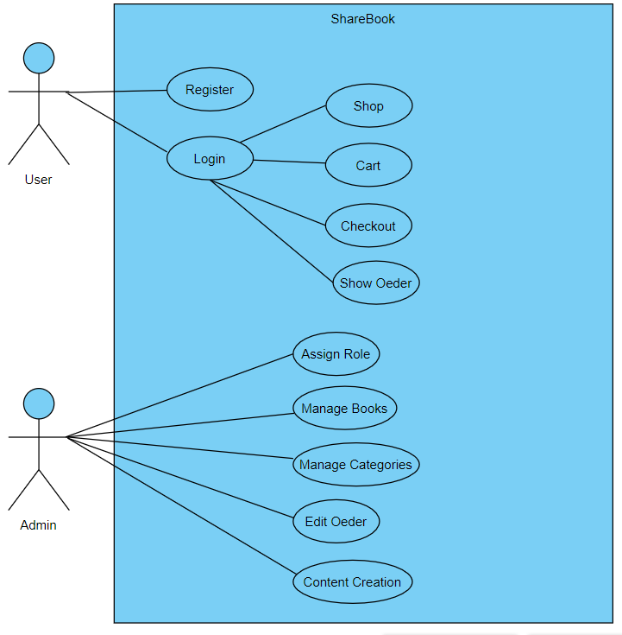

**Users Role:**

1) Admin: manage users, categories, books, content in admin dashboard pages.

2) User: create an account, review books, add to cart, checkout, buy a book, modify personal information.

**Database Diagram:**

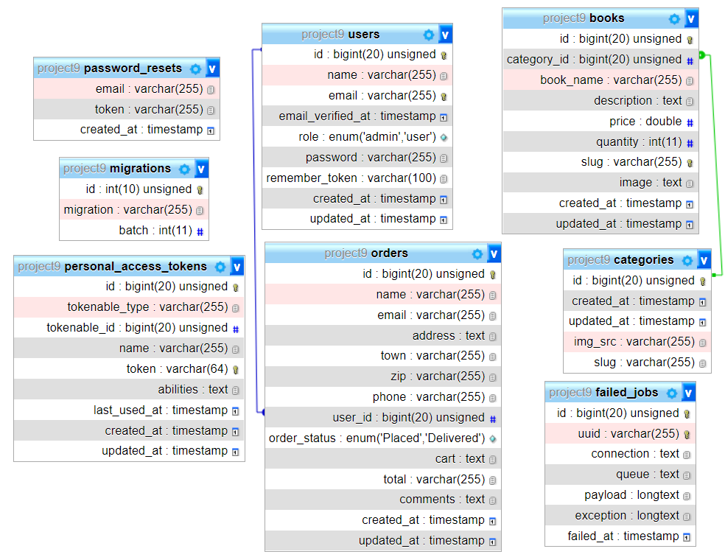

**Logic:**

1) Each category has many books (one-to-many).

2) Each user has a cart; each cart has many books (one-to-many).

3) Each Book belongs to one category.

4) Each User has many orders (one to many).

**Future Works:**

1) Make filter options based on price.

2) Make a search box, so the user can search for a specific book.

3) Add another payment method.

4) Allow the user to write a review and rate the book.

**Wireframes:**

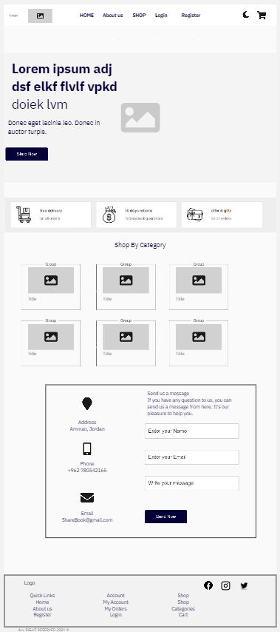

Landing Page

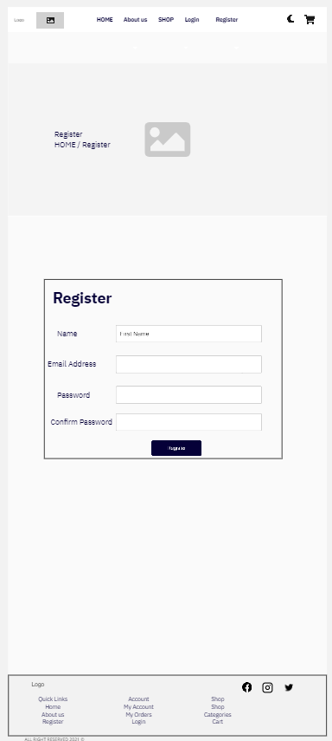

Register Page

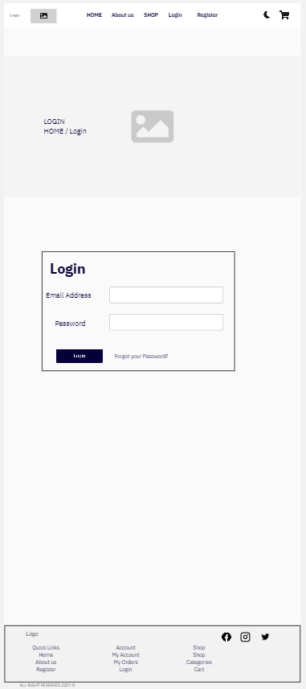

Login Page

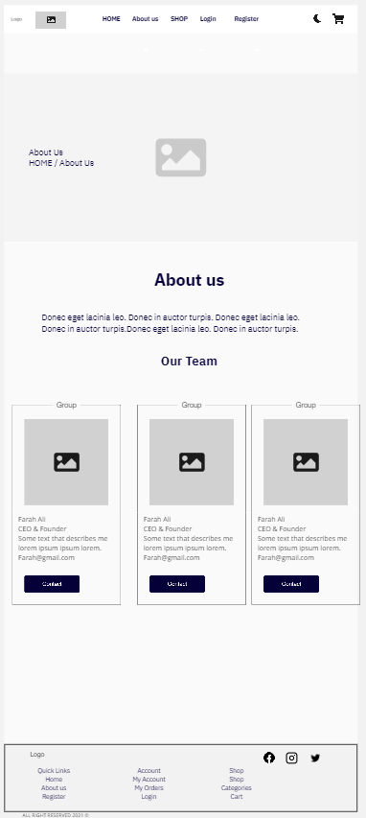

About Us Page

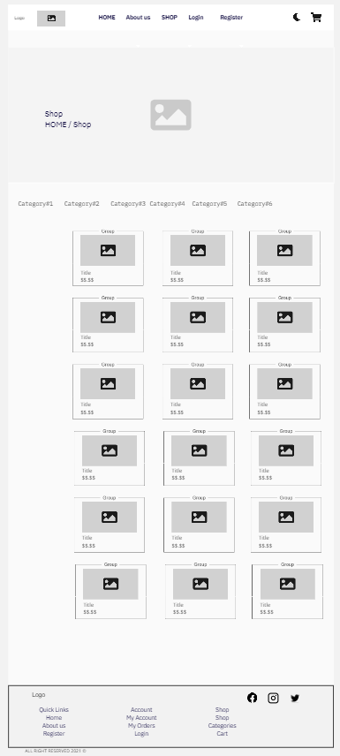

Shop Page

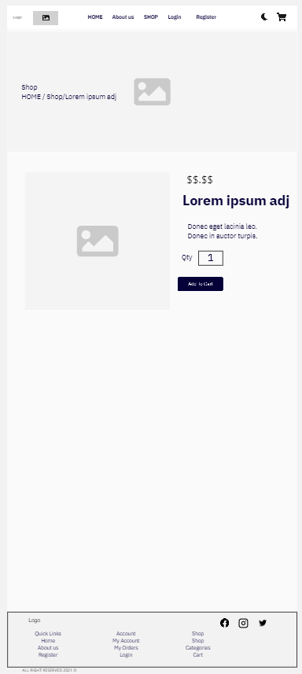

Single-Product Page

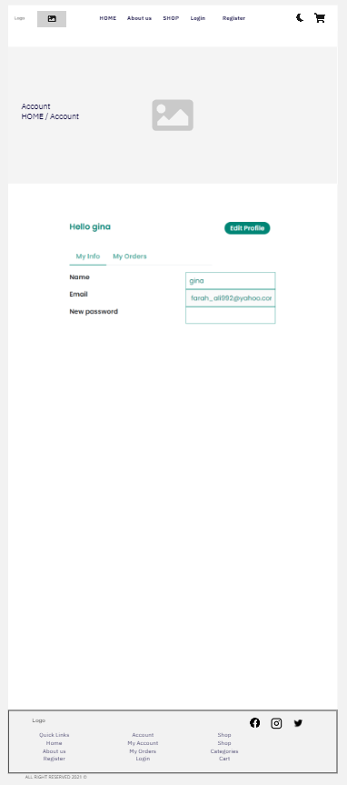  
Account Page

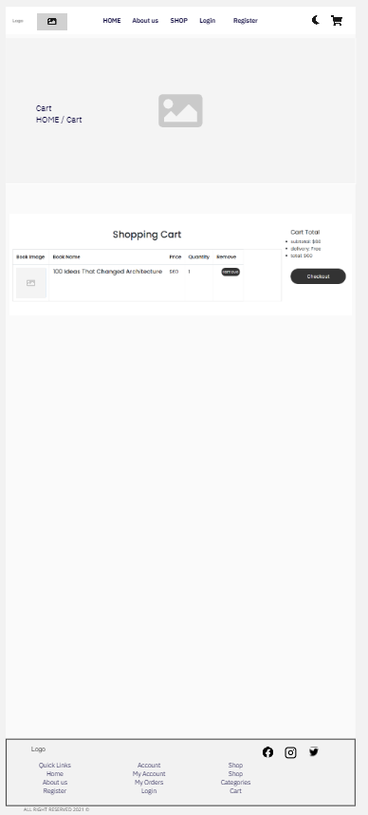

Cart Page

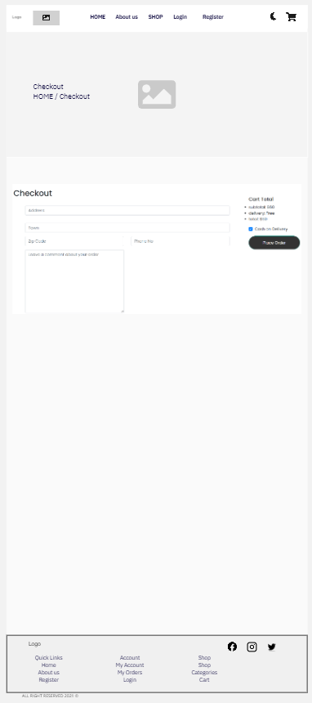

Checkout Page

**Mockups:  
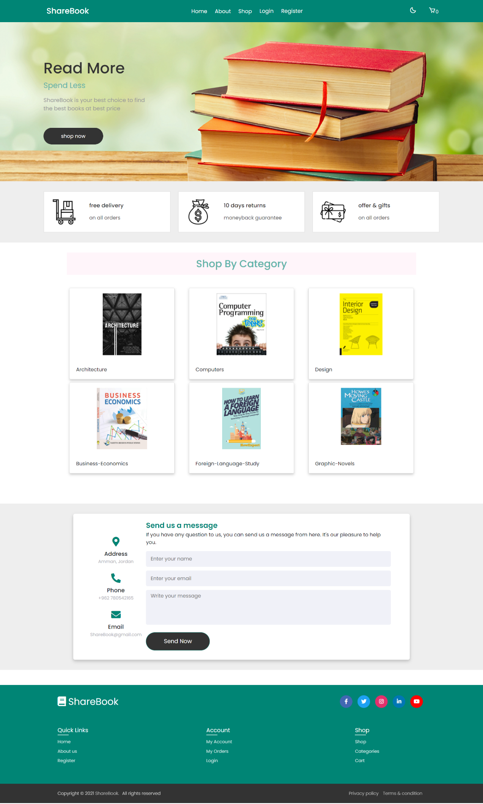**

Landing Page

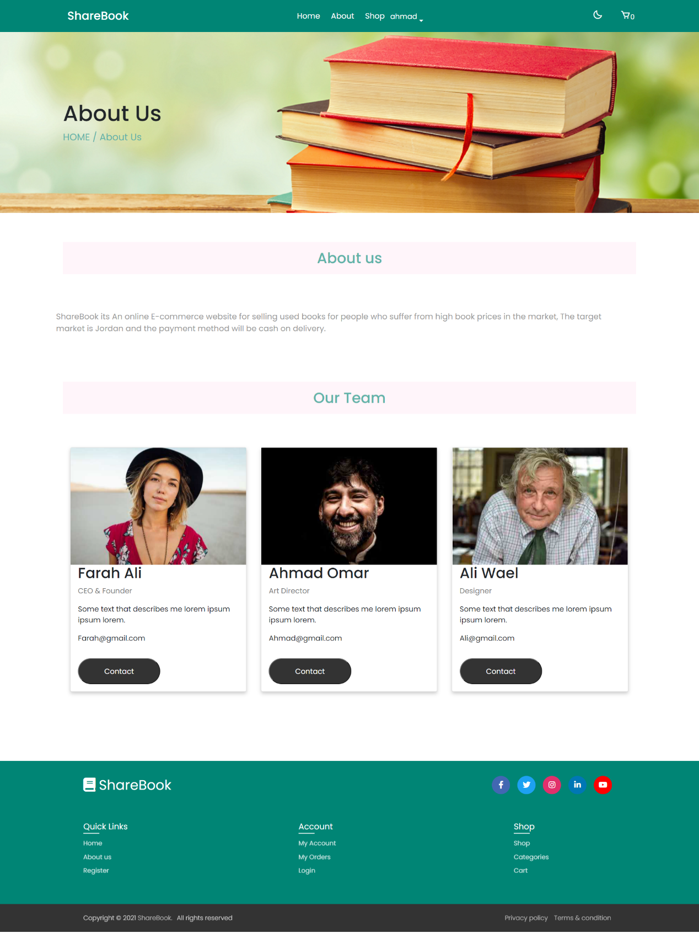

About Us Page

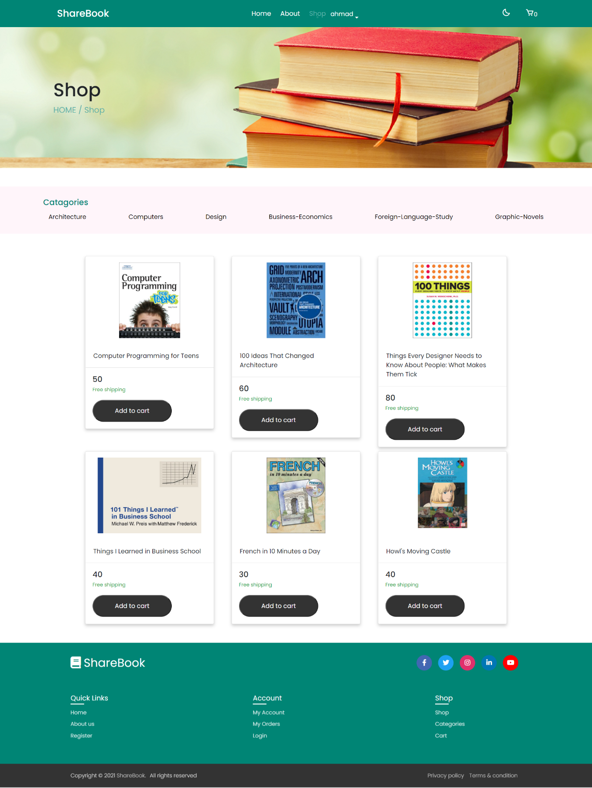

Shop Page

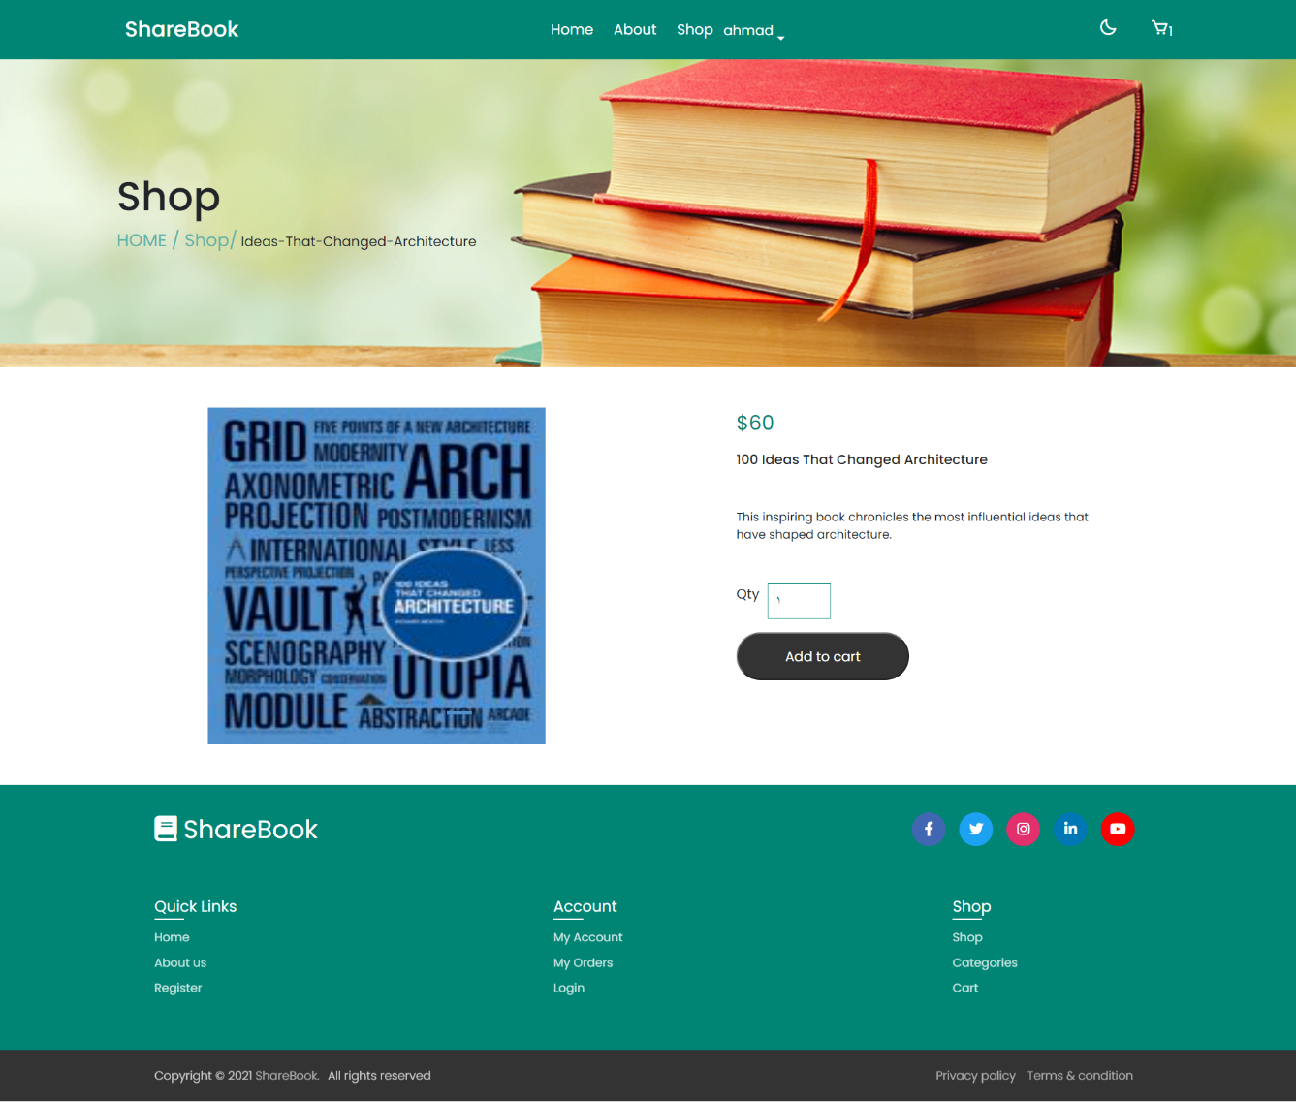

Single Product Page

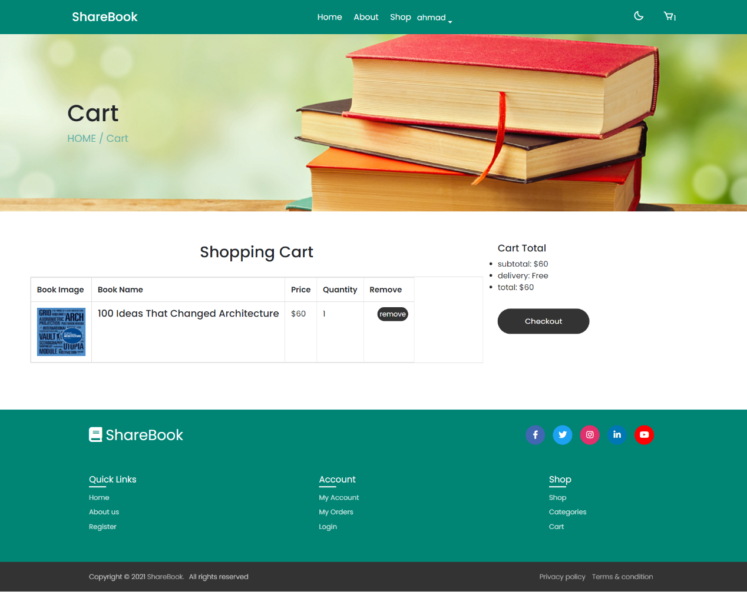

Cart Page

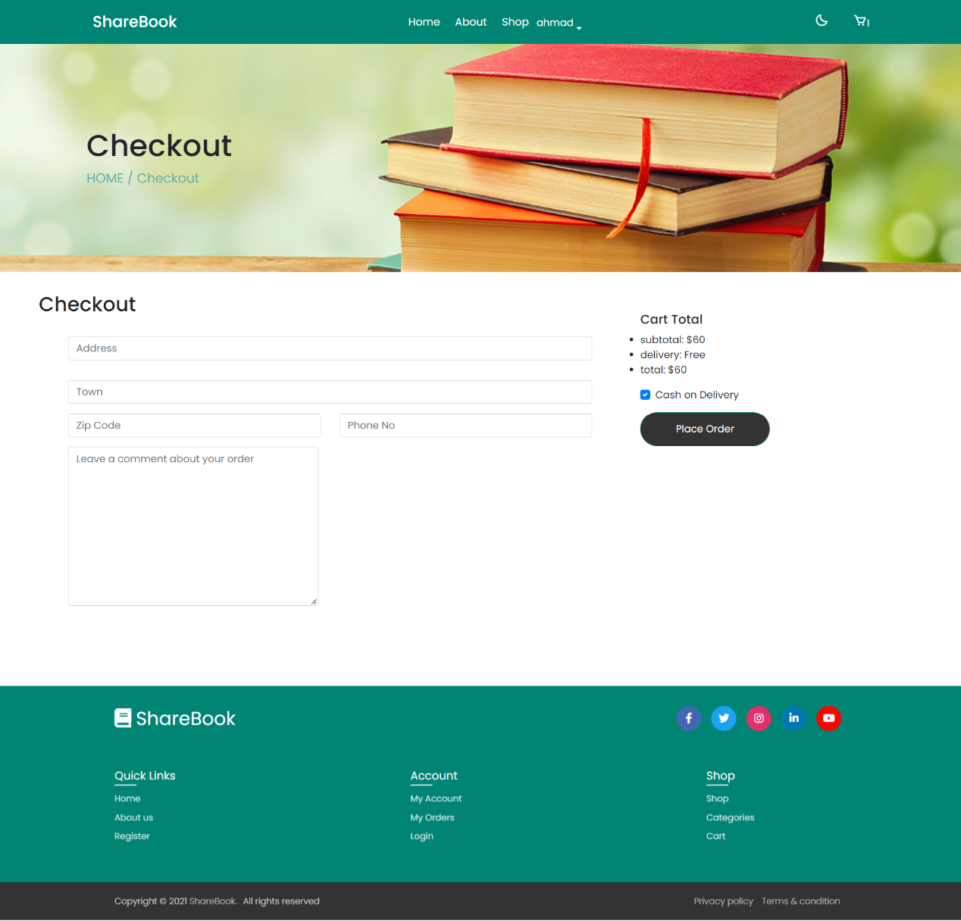

Checkout Page

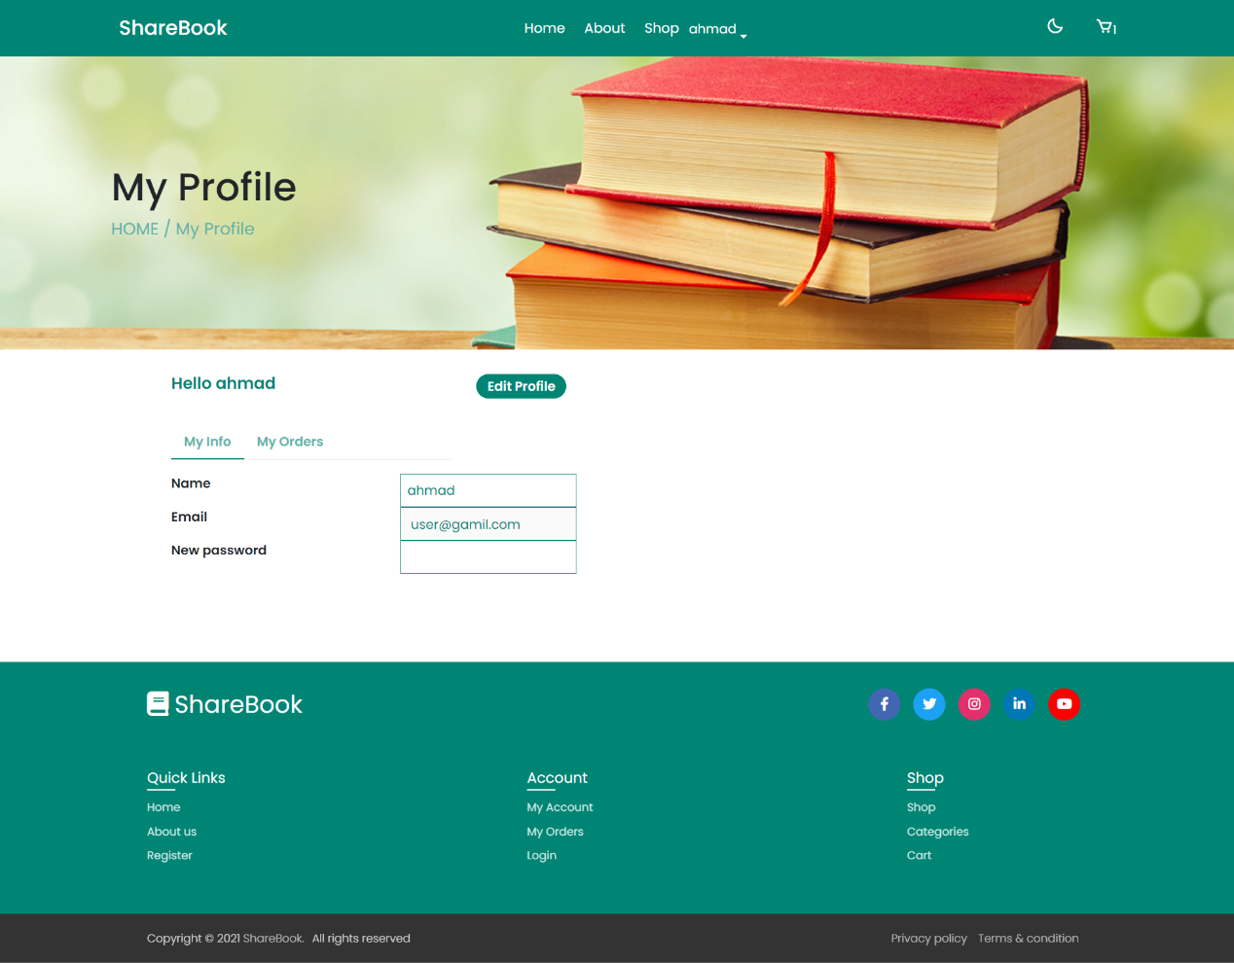

Account Page